**CENWP-ODJ8/8/2023**

**MEMORANDUM FOR THE RECORD**

**SUBJECT: *23JDA31 Sockeye and Chinook Morts in Gatewell 1C***

On Tuesday 8 August 2023, at approximately 0800, JDA fisheries personnel found an adult sockeye mort and 1 Chinook subyearling mort in gatewell 1C. They were removed from the gatewell, scanned for PIT tags (no tags) and returned to the river. The morts were several days old. The juvenile subyearling had marks resembling a walleye strike and the adult sockeye had some bacterial injuries. Personnel will continue to perform daily gatewell inspections to ensure no other mortalities appear.

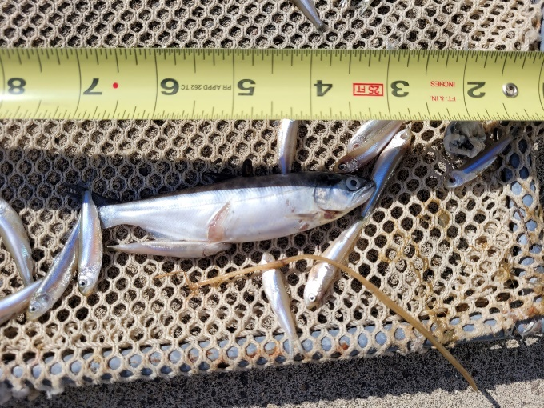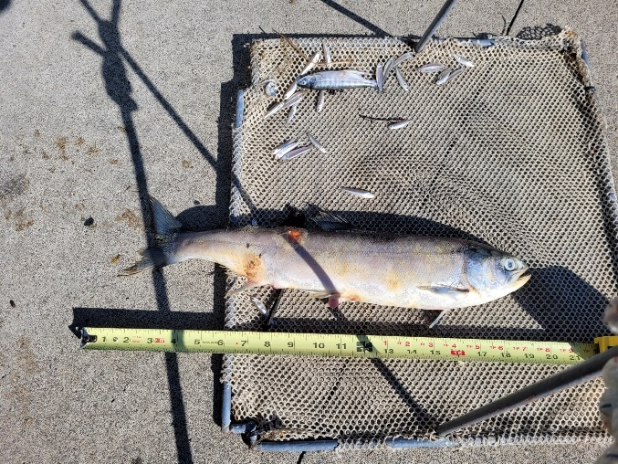

1. Species – Sockeye and Chinook subyearling
2. Origin – Unclipped and clipped
3. Length – Subyearling ~9cm and sockeye ~40cm
4. Marks and tags – Clipped Chinook subyearling
5. Marks and Injuries found on carcass – subyearling walleye strike sockeye bacterial infection.
6. Cause and Time of Death – Presumably from their injuries – time of death unknown
7. Future and Preventative Measures – Continue performing daily gatewell inspections.

Sincerely,

JDA Project Fisheries